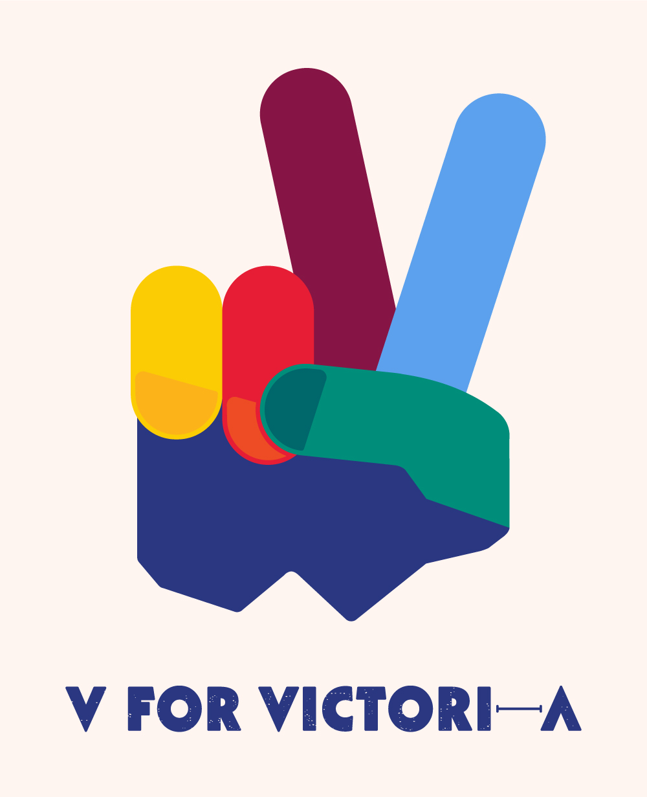

V FOR VICTORIA: A SYMBOL OF SUPPORT

JOIN MELBOURNE ICON MOLLY MELDRUM TO
SEND A POSITIVE MESSAGE TO VICTORIANS!

Media release – for immediate release
September 2020

Who remembers the V-shaped peace symbol of the sixties and seventies when flower power was all the rage? Or when Winston Churchill raised his ultimate ‘V for Victory’ unifying his country after a devastating war? From peace to war and now to lockdown, the ‘V’ takes on another role. The ‘V for Victoria’ initiative, created by Victorian designer Charlie Ryan, is starting to gather some pace. But like Uncle Sam – WE NEED YOU to help spread the word!

Initially developed as a direct response to Victoria going into tough COVID-19 lockdown restrictions and the ongoing closures of state and territory borders, the campaign launch coincided with a well-publicised rise in negative media and online coverage towards Victorians that inflamed further fear, anger and division between the states.

“Having seen our country come together over the summer bushfire crisis so recently, I just didn’t believe the negative words and sentiment directed towards Victoria in its time of crisis accurately reflected the real sentiment of everyday Australians. I firmly believe that there should be more words of love, hope and solidarity and I want ‘V for Victoria’ to encourage that,” said Charlie. Awwww.

Charlie has repurposed the ‘V’ in a strong graphic way, to represent our united fight for victory against COVID-19 and its flow-on effects throughout our greater community. Its design thoughtful and inclusive, the graphic has been designed with the official colour of Victoria (blue) adjoining the colours that represent all other Australian Commonwealth states and territories. He’s clever that Charlie.

Since August, Charlie’s studio, Five Creative, has been spreading this unifying message of love, hope and solidarity, firstly in Melbourne and now into Sydney, too, to raise the plight of the Victorian community under harsh lockdown conditions.

So far, #VforVictoria has generated much hype on its own. With initial funding from Five Creative and a ‘Go Fund Me’ campaign, hundreds of street posters are already donning the streets of Melbourne and Sydney. With an Instagram page @vforvictori_a and a Facebook community page: @vforaustralia, followers are encouraged to post images of themselves holding up the ‘V’! Even Melbourne icon and proud Victorian Molly Meldrum, has responded to the call! Take a look and join the tribe.
Charlie has also created a range of locally produced prints, face masks and apparel available at www.vforvictoria.com.au, along with a range of free-to-download versions of the artwork, which have been particularly popular with children. One hundred percent of any profits generated from the sale of merchandise will go directly back to the distribution of the #VforVictoria messaging.

Charlie continued, “The big V is something to remind us that we’re not alone, but all in this together. With a safe, simple and unifying hand gesture we can send a message of love and hope across Victoria, Australia and beyond.” Who doesn’t need that?

For additional information, visit: www.vforvictoria.com.au
Or follow the campaign on Instagram: @vforvictori_a and Facebook: @vforaustralia using the hashtag #VforVictoria.

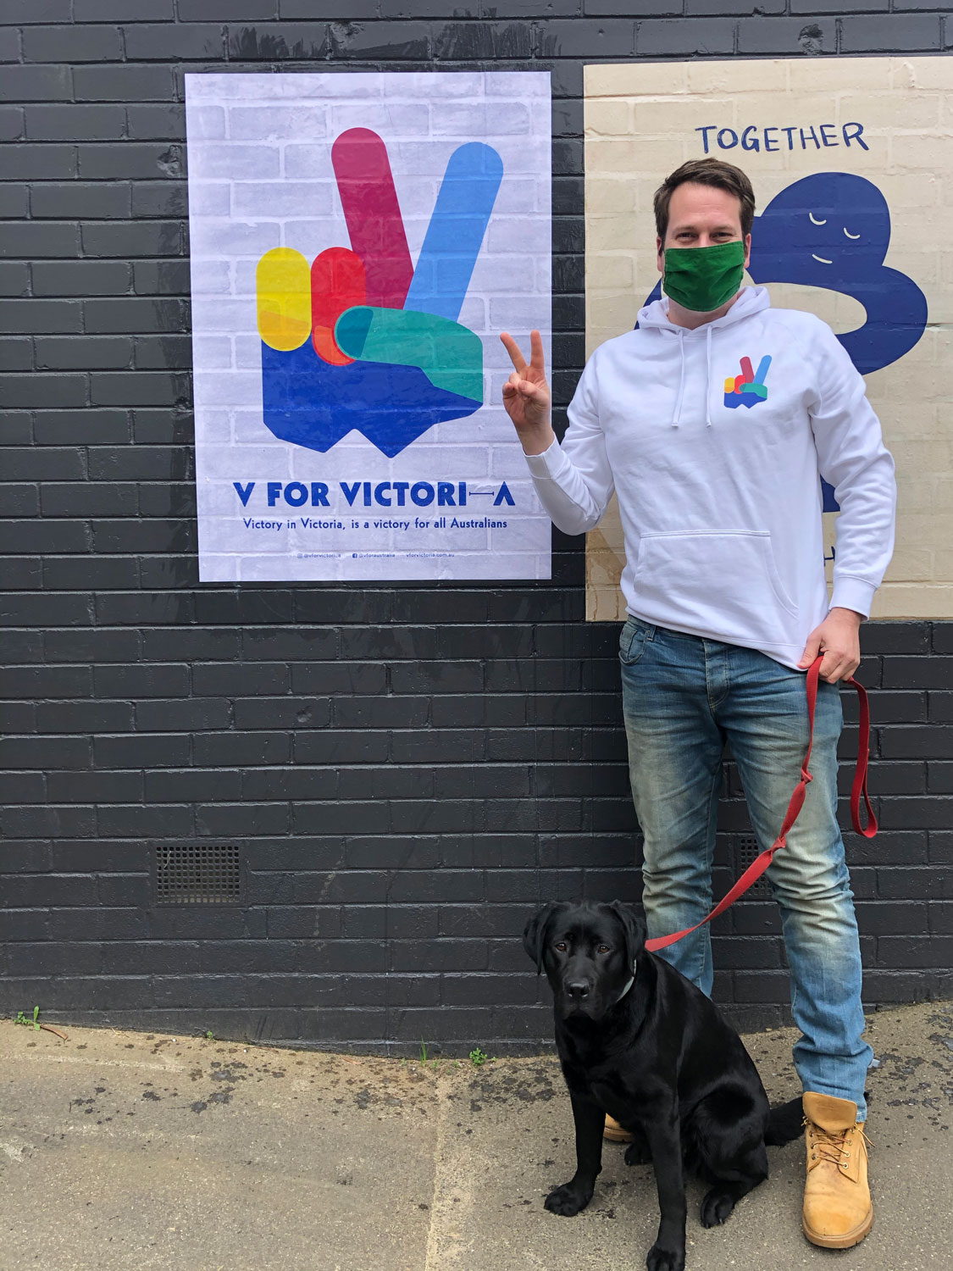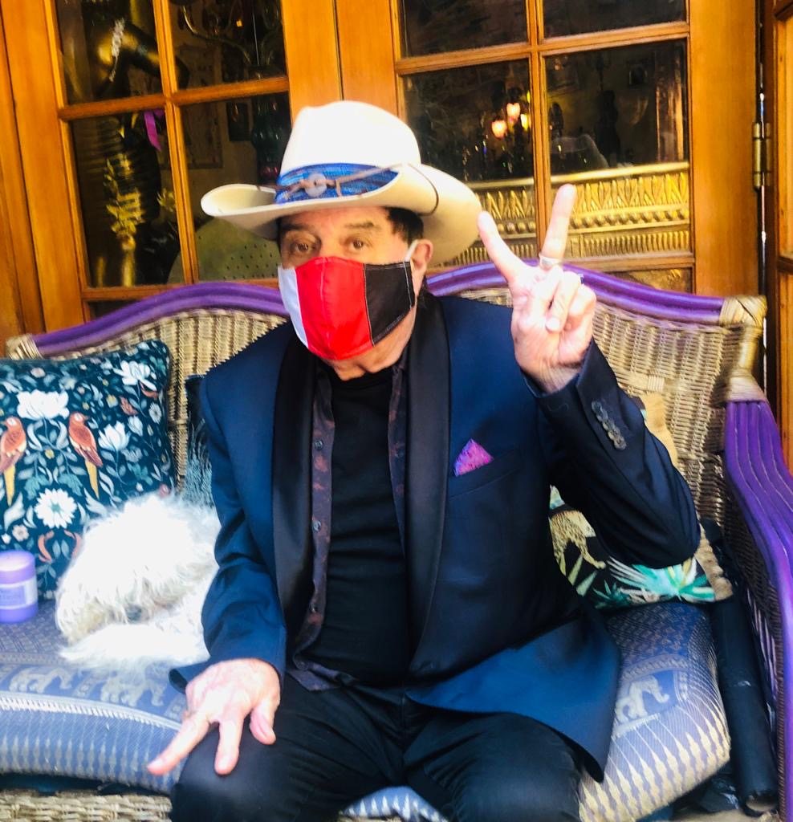
Charlie and his dog Navy, with one of Music legend Ian ‘Molly’ Meldrum gives
the posters in Melbourne the #VforVictoria on Instagram

ENDS

Interviews with Charlie Ryan and additional images are available on request.

For all media enquiries please contact Kathy Lane, FireWorks PR & Events
M: 0419 392 183 or E: kathylane@fireworkspr.com.au

About Charlie Ryan
Charlie Ryan is a contemporary Australian artist and designer, based in the hinterlands of the Mornington Peninsula, Victoria. He is the Creative Director of Five Creative and as an artist, he paints, illustrates and writes, exhibiting regularly. For additional information, visit www.charlieryan.com.au

About Five Creative
Co-founded by Charlie Ryan and James Baker in 2009, Five Creative is a Melbourne based design agency, specializing in Brand, Web and Design. For additional information, visit: www.fivecreative.com.au

